* Write a program to accept five numbers, store them in a integer array and print the numbers

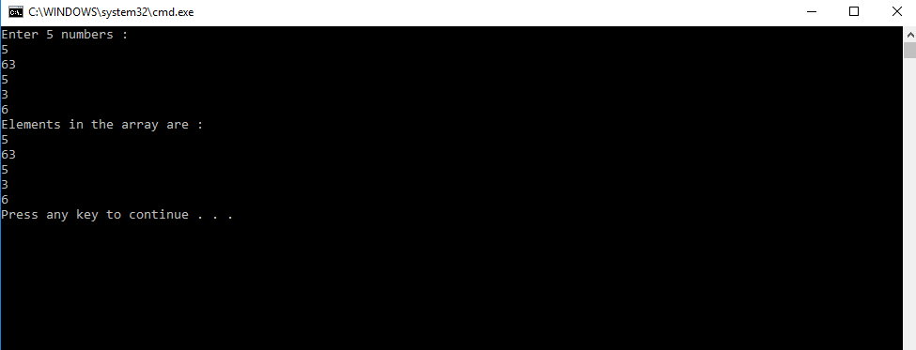

* Write a program that uses arrays to multiply matrices together. The program will read four integer values from the console and store them in a 2 x 2 integer matrix. It will then read another four integer values from the console and store them in a second 2 x 2 integer matrix. The program will then multiply the two matrices together, storing the result in a third 2 x 2 integer matrix. Finally, it will print the resulting matrix to the console. The formula for multiplying two matrices—A and B—together is as follows:

A1 A2 B1 B2 A1.B1 + A2.B3 A1.B2 + A2.B4

A3 A4 B3 B4 A3.B1 + A4.B3 A3.B2 + A4.B4

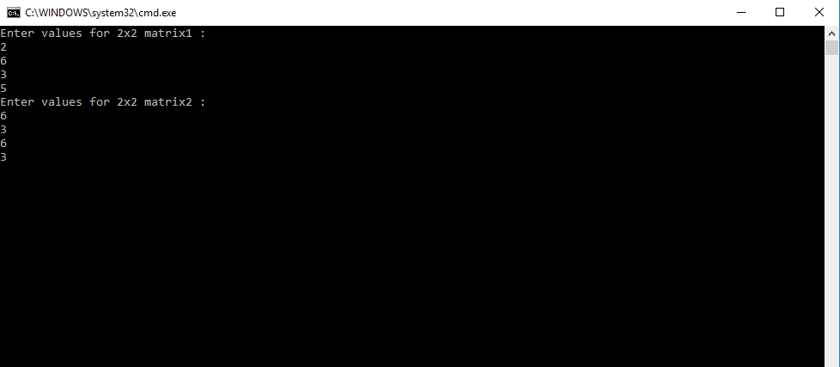

* Write a static method called Method that returns an array of ints of rank 2 and expects no arguments. The body of Method will contain a single return statement. This statement returns a newly created array of rank 2 with dimensions 3 and 5 whose 15 elements are all initialized to 42.

